ICTPRG302 - Apply introductory programming techniques –

Session 5 Worksheet

Conditional Instructions

Task 1. Write a program to check whether a person is eligible for voting or not. Use the following code:

# this program will check whether a person is eligible for voting

age=int(input("Enter your age")) # to avoid error enter a valid number

# Enrolment and voting is compulsory for every Australian citizen aged 18 years or older.

if … # write your code instead of …

print(“Eligible for voting, you are: “, …) # write your code instead of …

print("Enrol to vote, and to keep your details current.")

else:

print(…) # write your code instead of …

Output(example):

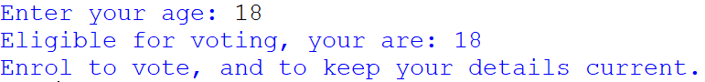

Task 2. Write a Python program to check the validity of password input by users.

Validation Requirements:

* Minimum length 9 characters. Maximum length 15 characters.
* Only letters (alphabet). Every character must be in uppercase.

Use the following code:

# Python program to check the validity of a password

# Password lenght should be between 9 to 15 characters

# Password is a combination of uppercase letters only

password = input("Enter your password: ")

**if** …< 9 or len(password) >= 15: # replace … with your code

print("Invalid password. Wrong length.")

**elif** password.isalpha() == …: # replace … with your code

print("Not all characters in string are alphabetic letters (A-Z].")

**elif** … == False: # replace … with your code, use isupper() method

print("Not all characters in string are uppercase [A-Z].")

**else:**

print(…) # replace … with your code

Output (example):



*End of workshop.*